## Module – 3 Network

**Assignment 1:** Create VPC with 2 subnets and launch 2 instances to check the communication between two Instances.

Below are the steps to establish communication between two ec2 instances.

Step 1: Click on ‘Create VPC’ and configure below properties –

1. Resources to create – Click on ‘VPC and more’
2. For all vpc resources name tag – put the name
3. IPv6 CIDR block – choose ‘No IPv6 CIDR block’
4. Number of availability zones – Choose 2
5. Number of public subnets – Choose 2
6. NAT gateway – choose in 1AZ

Click on ‘Create VPC’.



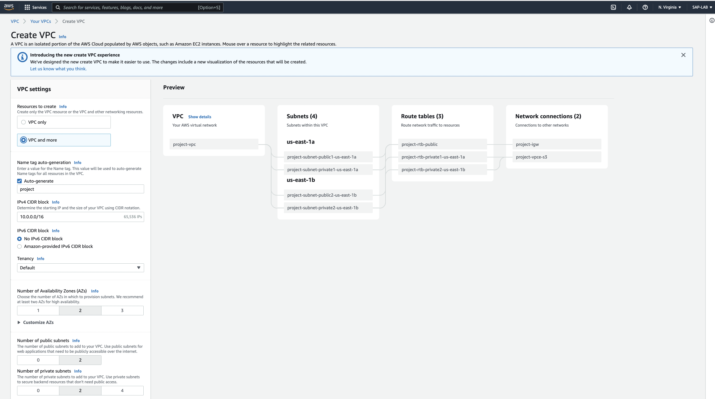

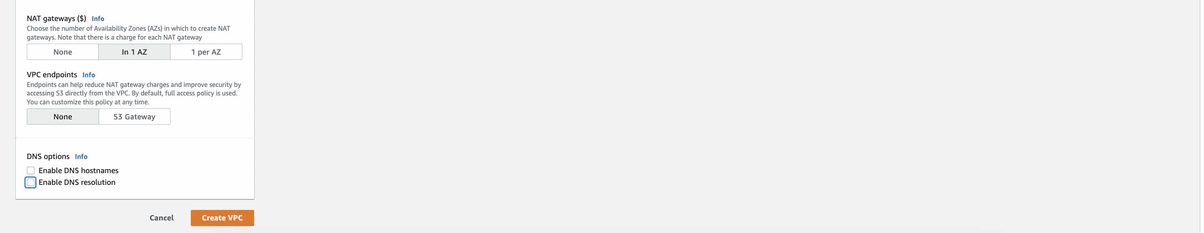

Step 2: Create 2 different EC2s in different subnets and configure properties as below and click on ‘Launch Instance’.

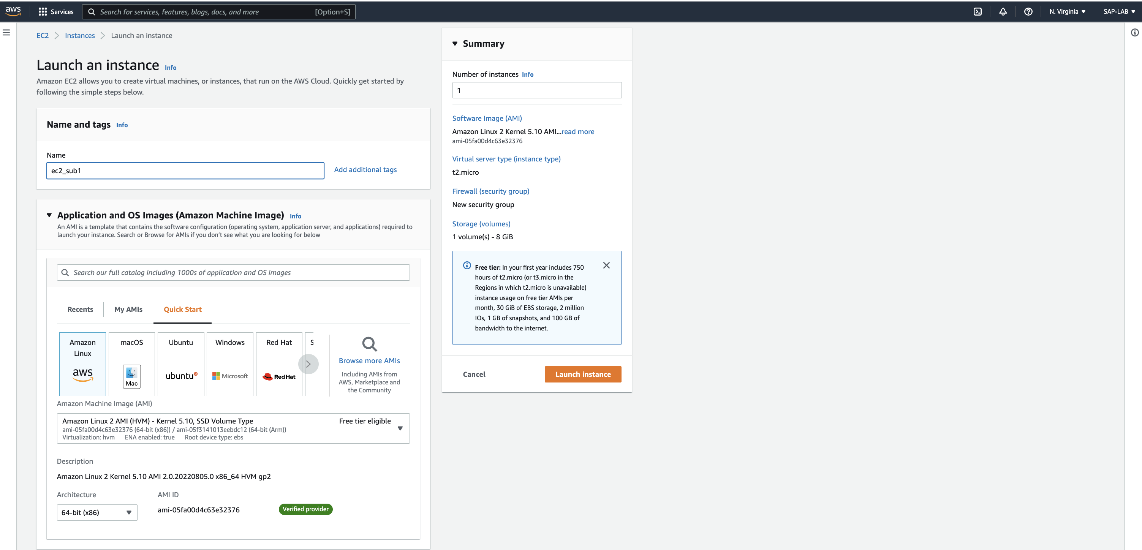

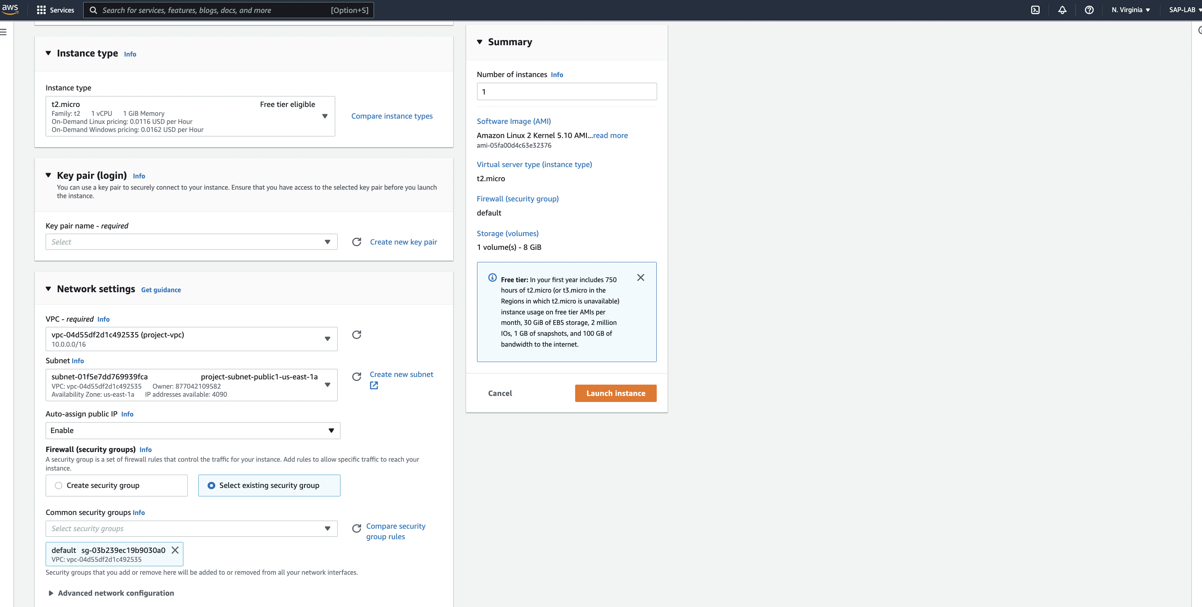

Click on the ‘Security Group’ of EC2 instance and edit the inbound rule of security group for both EC2.

Enter the IP address of other EC2 instance to allow traffic.

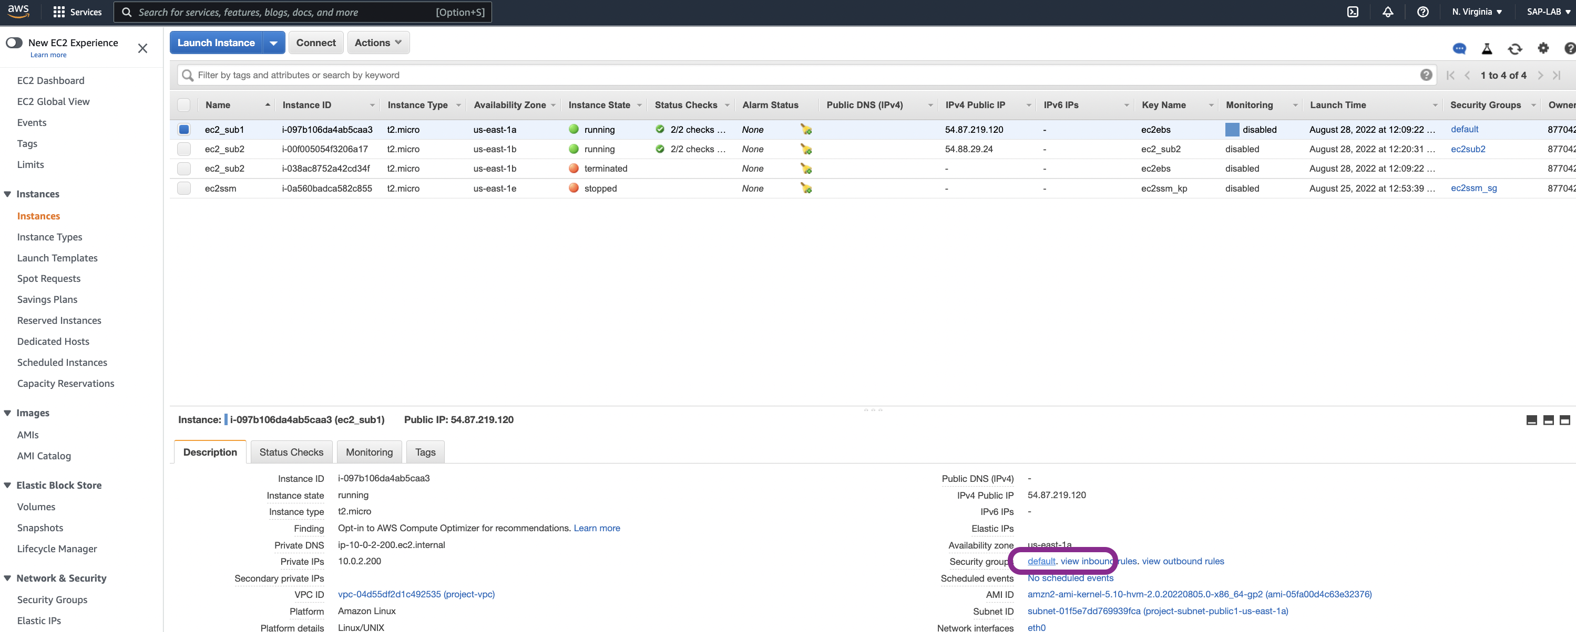

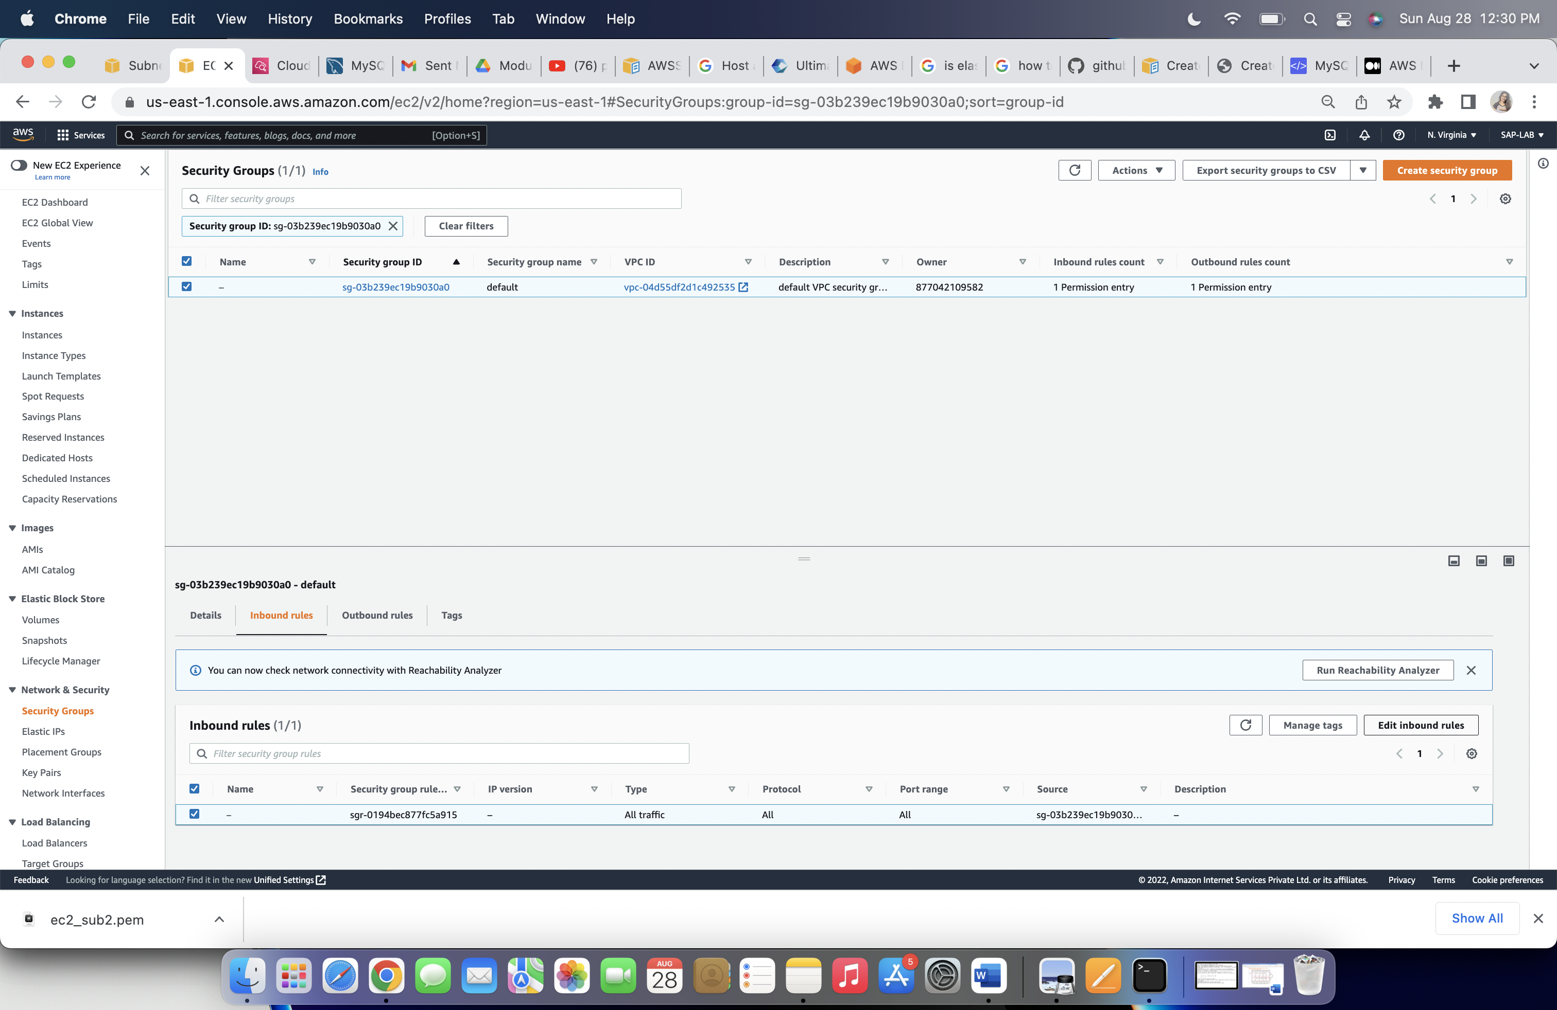

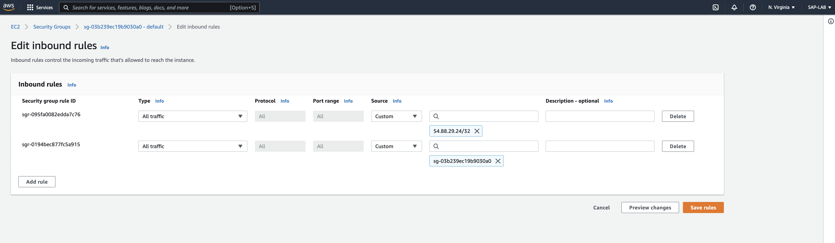

Step 3: After allowing traffic from other instance, connect SSH. Open the terminal on the your machine and execute below commands for actions.

1. Go to the directory, you saved key-pair file,

**cd <directory-name>**

1. Use the chmod command (in bold below) to make sure your private key file isn’t publicly viewable

**chmod 400 <key-pair-filename>**

1. SSH to your EC2 instance

**ssh -i /path_to_key/ec2m4a1.pem ec2-user@public_dns_name**

It will show [ec2-user@ec2-publicIP] on command line

Type ping <ec2-publicIP>, to terminate the packet transmission press ’ctrl+C’. It will show transmitted and received packet status.

